

IT2010 – Mobile Application Development

BSc (Hons) in Information Technology

2nd Year

Faculty of Computing

SLIIT

**2023 – Lab Exam 01**

**Report**

|  |  |
| --- | --- |
| Student ID | IT22579454 |
| Batch | 10.2 |
| Student Name | M.A.S.S.Marasinghe |

**DreamScapes**

**Description**

DreamScapes is your ultimate destination for high-definition wallpapers, offering a seamless blend of curated collections and personalized uploads. With DreamScapes, users can immerse themselves in a world of stunning imagery to enhance their digital spaces. Upon logging in via email or Facebook, users gain access to a vast array of categories and popular wallpapers, meticulously organized for easy exploration. Whether seeking breathtaking landscapes, captivating cityscapes, or abstract artistry, DreamScapes caters to every taste. Additionally, users can contribute to the community by uploading their own wallpapers, sharing their creativity with fellow enthusiasts. With a user-friendly interface and an extensive library of high-quality wallpapers, DreamScapes transforms device screens into captivating canvases, inspiring users to dream big.

**Key functions**

**Login Options:** Users can log in via email or Facebook ID to access personalized features and sync preferences across devices.

**Category Navigation:** Browse through a wide range of categories such as nature, architecture, animals, and more to discover wallpapers tailored to your preferences.

**Popular Wallpapers:** Explore a curated selection of popular wallpapers, showcasing trending and highly-rated images.

**Upload Feature:** Share your creativity with the world by uploading your own wallpapers, contributing to the diverse collection within the app.

**HD Wallpaper Downloads:** Download high-definition wallpapers with ease, ensuring crisp and vibrant visuals for your device screen.

**Search Functionality:** Quickly find specific wallpapers by utilizing the search feature, enabling efficient navigation through the extensive library.

**Favorites:** Save your favorite wallpapers for convenient access and create personalized collections to suit various moods and occasions.

**User Profile:** Customize your profile, track your uploaded wallpapers, and connect with other users within the DreamScapes community.

**Notification Alerts:** Stay updated with notifications about new uploads, featured collections, and community interactions.

**Target**

DreamScapes targets smartphone and tablet users who seek to personalize their digital devices with high-quality wallpapers. It appeals to individuals with a keen interest in aesthetics, photography, and digital art.

**Aims**

To provide users with a diverse and curated collection of high-definition wallpapers to cater to various preferences and tastes.

To foster a vibrant and engaged community of users who share and appreciate creative content.

To offer a seamless and user-friendly experience, prioritizing ease of navigation, accessibility, and personalization.

To continually enhance and expand the app's features based on user feedback and emerging trends in digital imagery.

To inspire creativity and self-expression by encouraging users to contribute their own wallpapers and engage with the community.

**\*** App Logo & Launching Screen

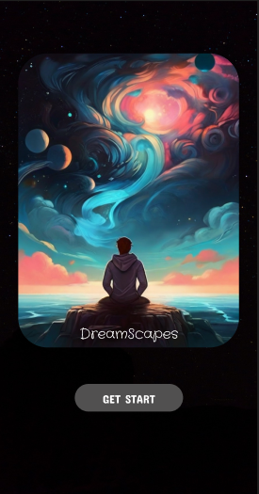

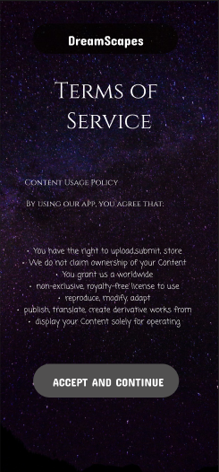

* Login interface

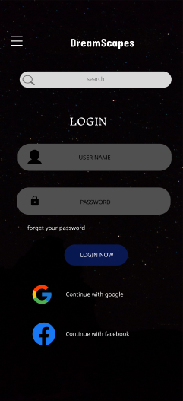

* Main Interface Design

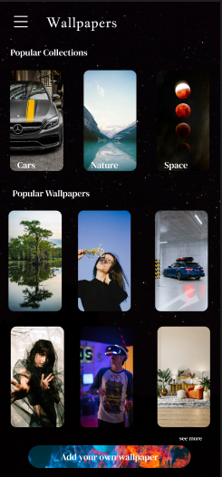

* Menu icon and interface

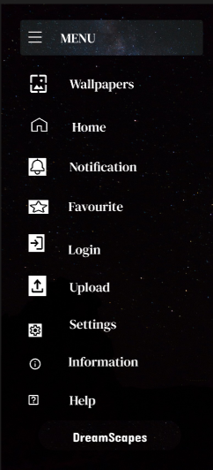

* Collections

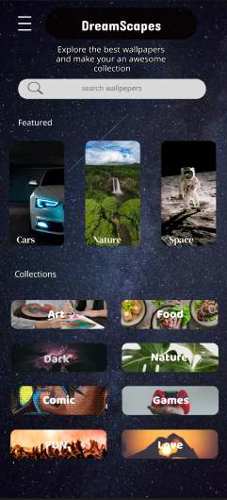

* Upload own wallpaper interface

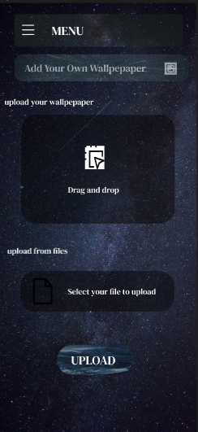

* Download wallpaper interface

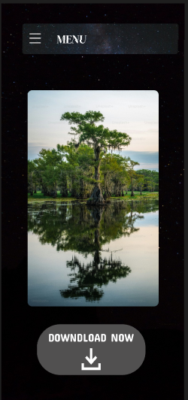

* Prototype Link

https://www.figma.com/proto/XWTMZ5cDJKkZdVxIvdhxJe/Untitled?node-id=2-269&scaling=scale-down&page-id=0%3A1&starting-point-node-id=2%3A269&mode=design&t=2qZ0zun05HyzU7HG-1